**PRACTICUM DATA WAREHOUSE**

**‘Jobsheet 1 – Input Data’**

Name : Sabrina Rahmadini

Student ID : 2341760155

Class : SIB 2G

* Open the Transformation worksheet via the File toolbar.

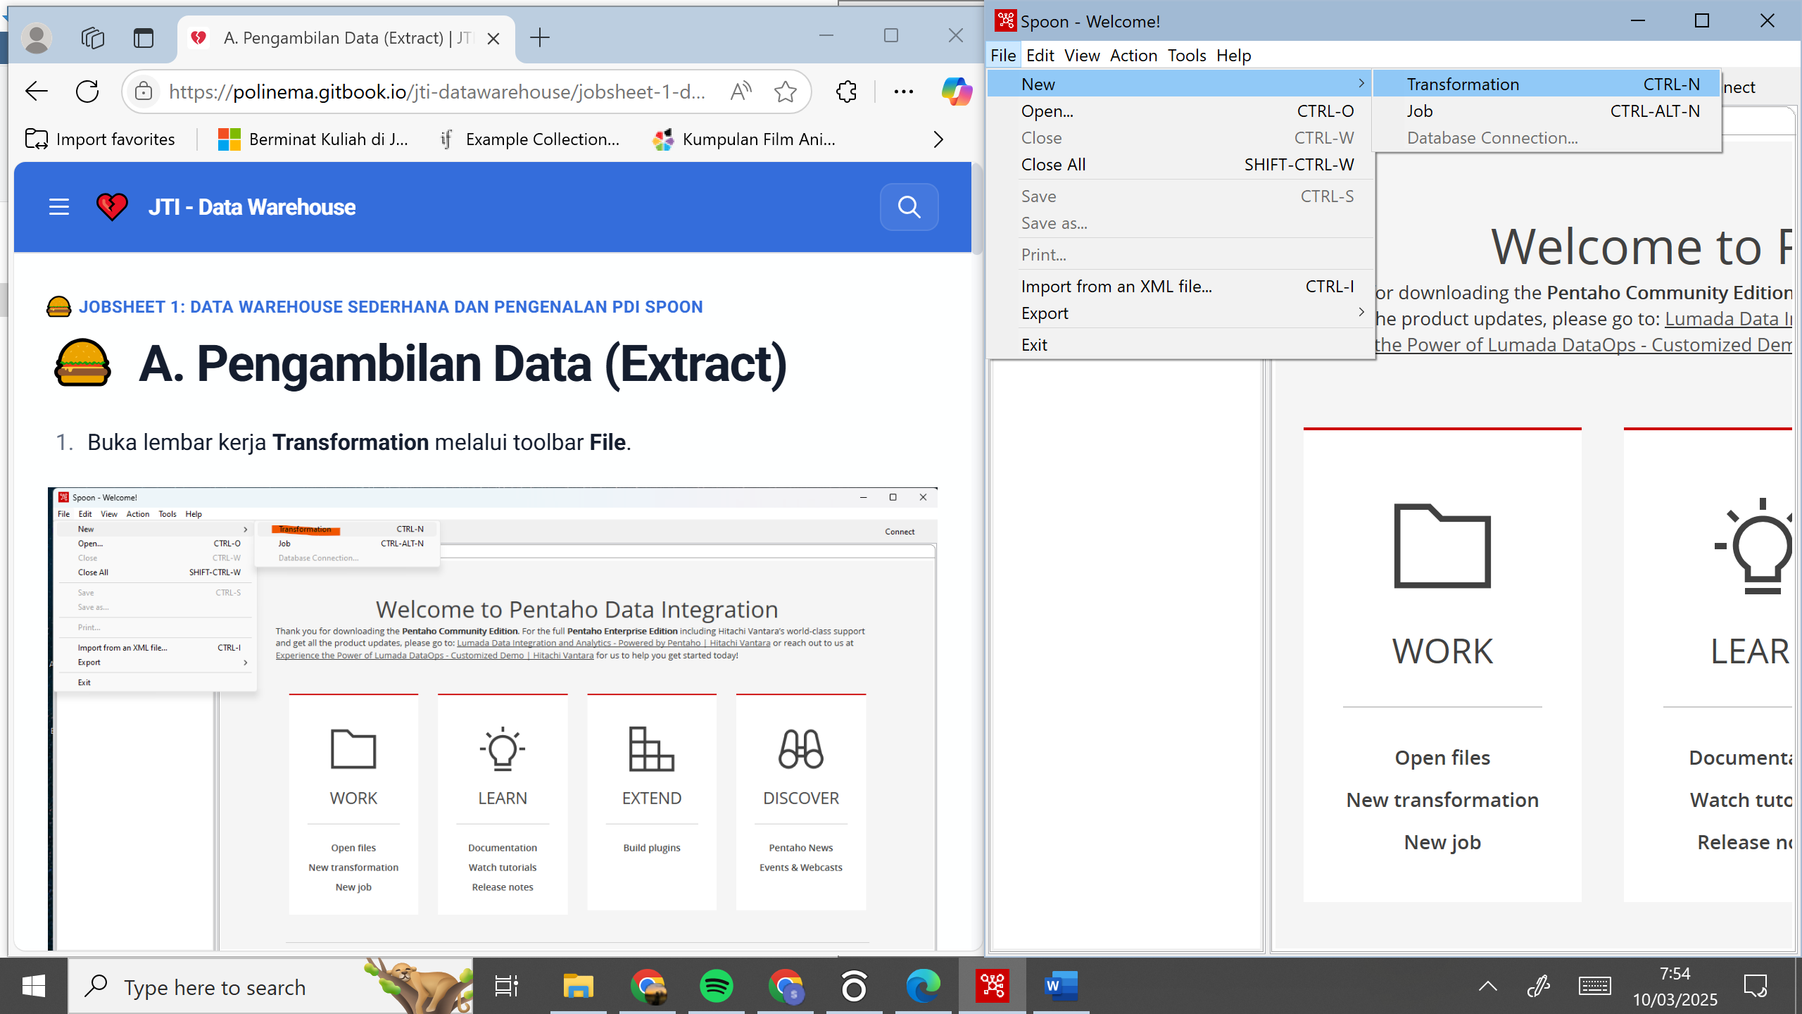

* Locate the CSV input file object in the Design Area. Drag and drop the object to the Work Area.

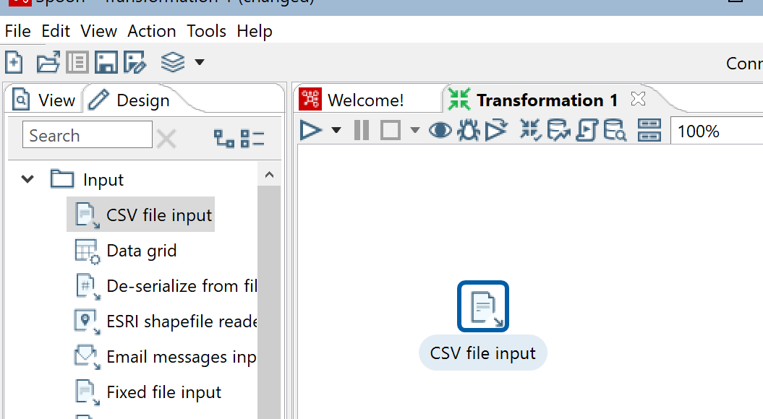

* Double-click on the CSV input file object until the configuration window appears.

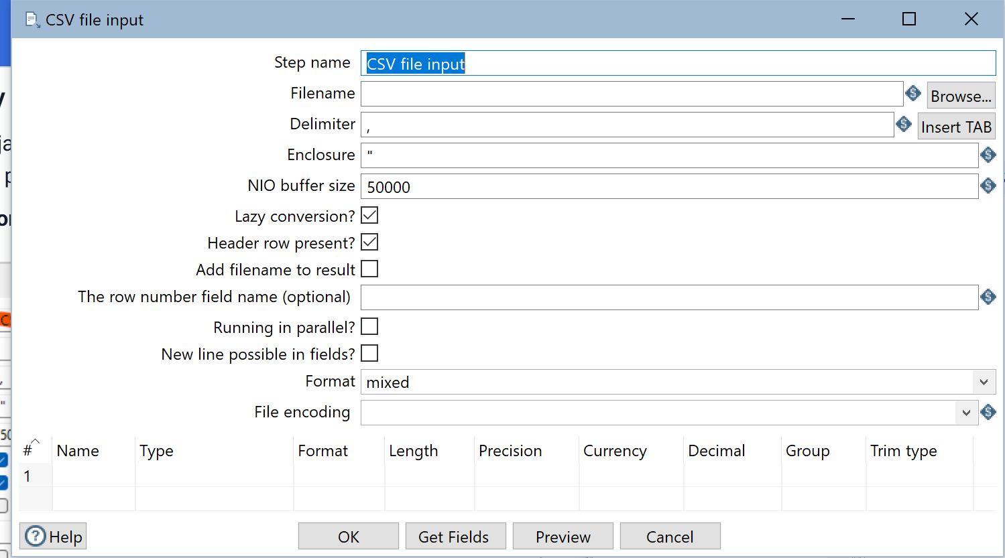

* Change the Step name to CSV Input Data, (naming is used for identification only, further naming can be adjusted).
* Select the location of the CarDistributionSales.csv file through Browse on filename.

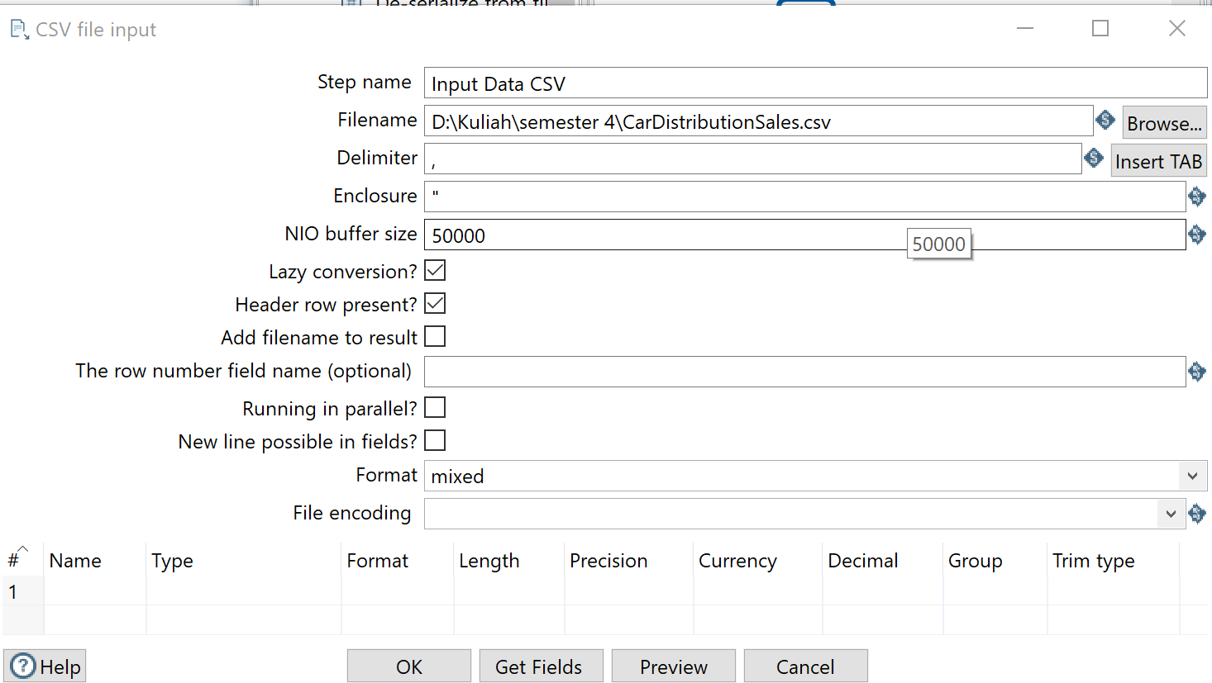

* If the data has been selected, make sure that the Delimiter section matches the data separator conditions in the selected file. (In this case it is comma “ , ” ).

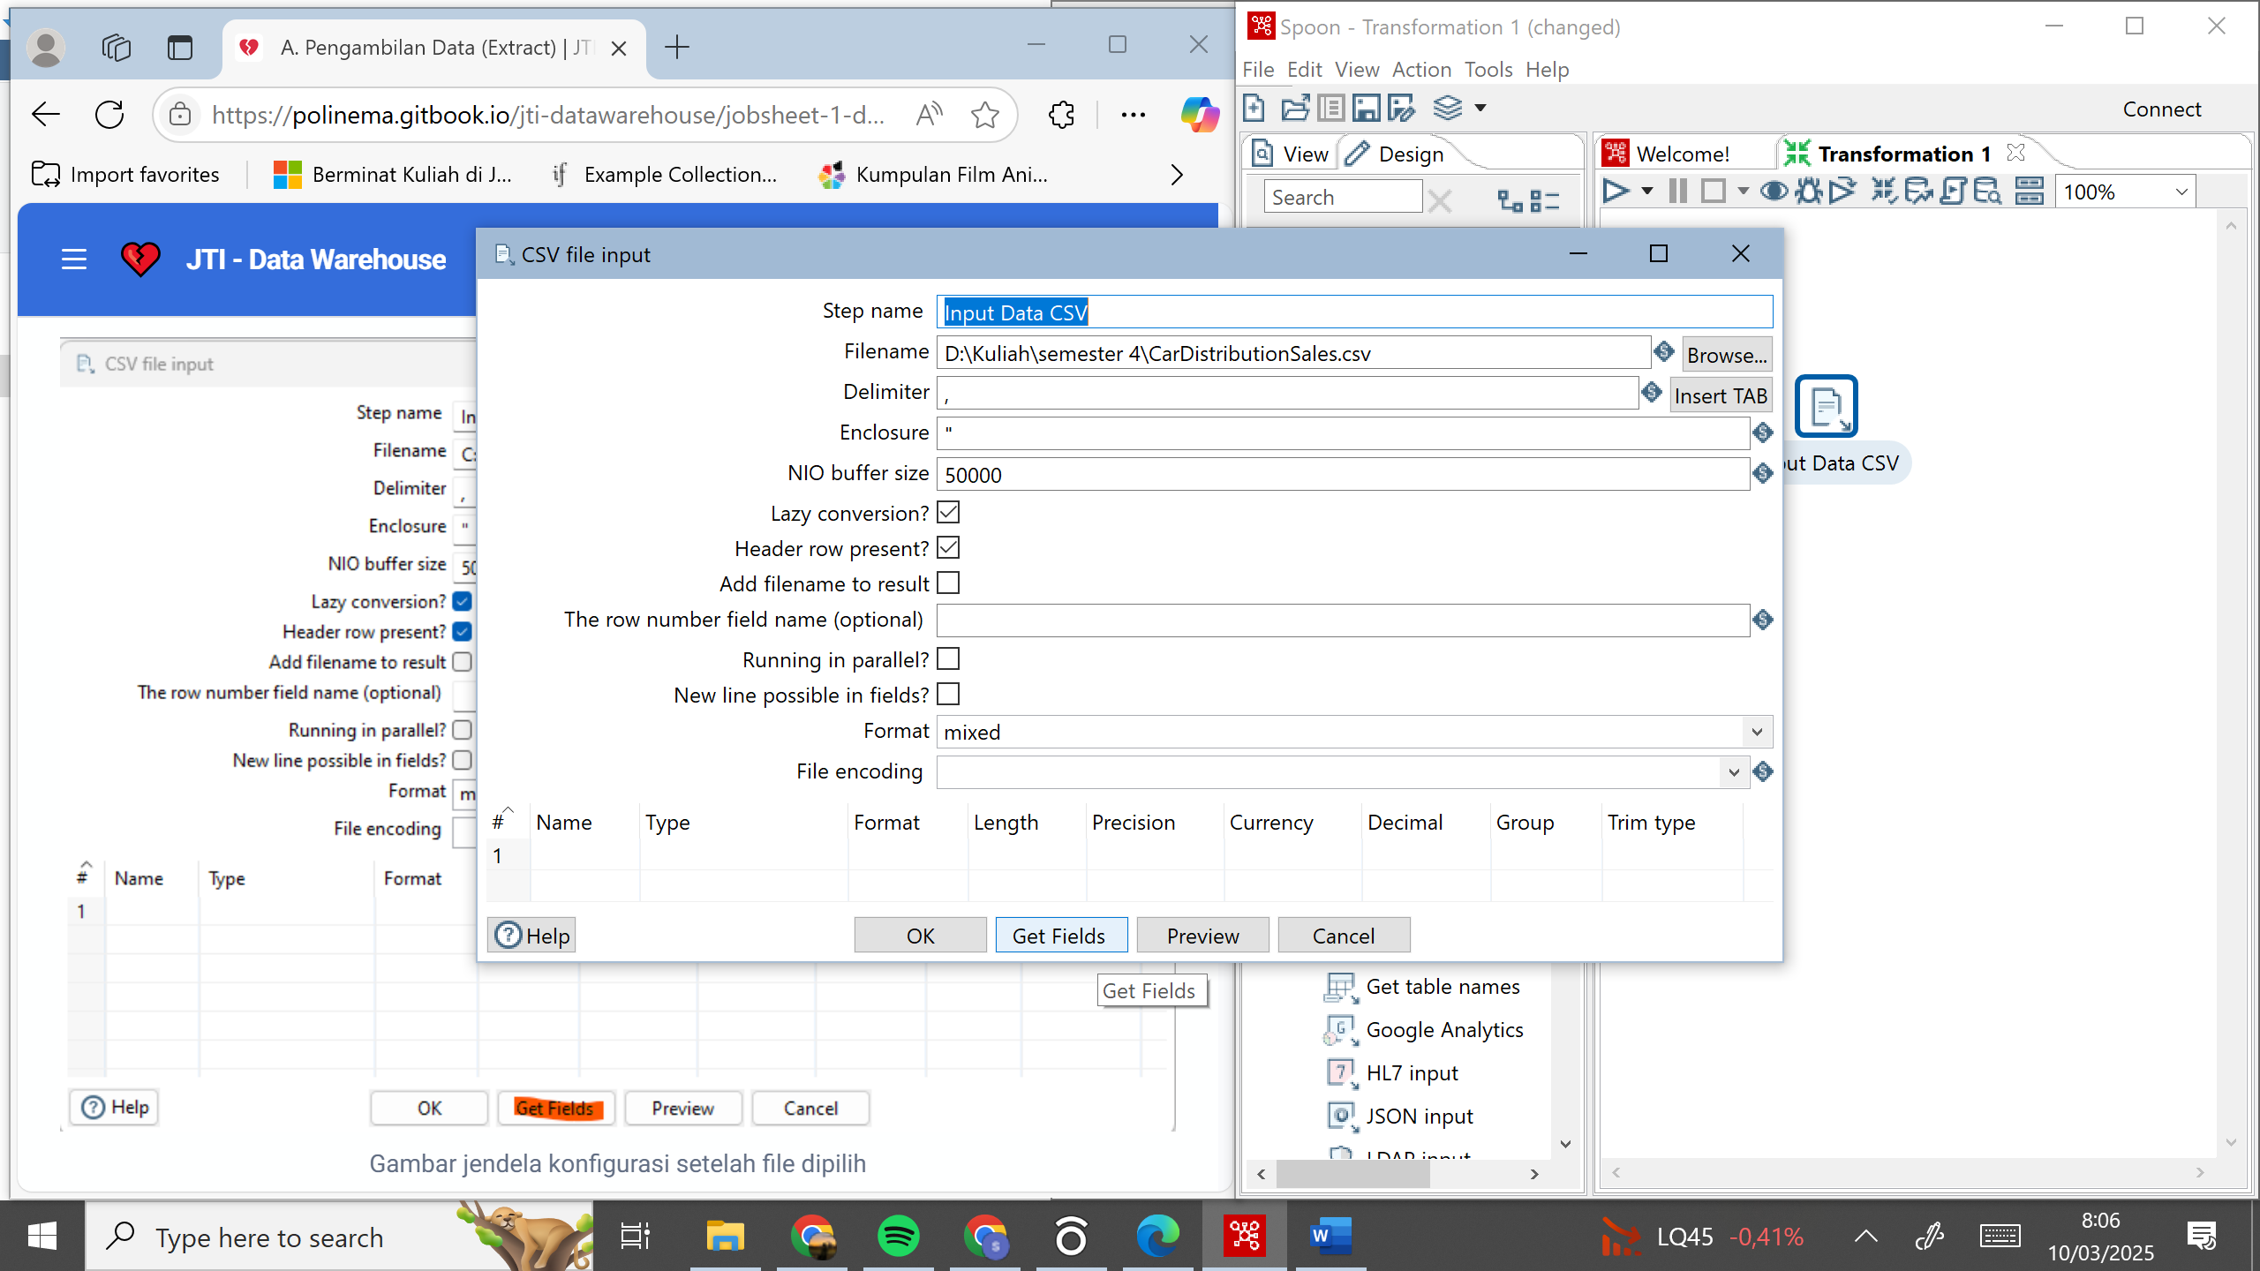

* Press Get Fields to retrieve the title of each column, make sure the column names are appropriate.



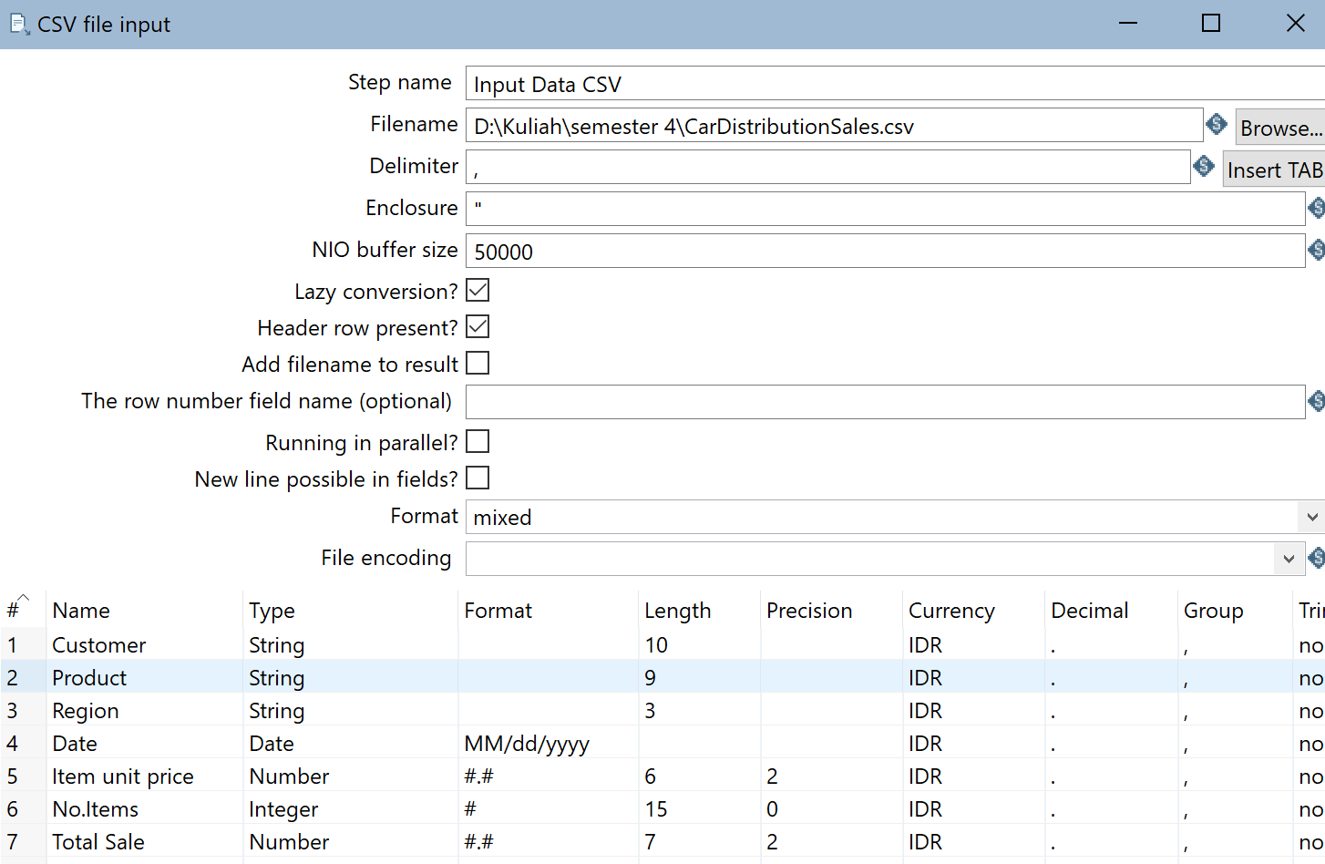

* Close the configuration window.
* Press the “Run” button on the top right corner of the Work Area, and the Execution Result Area will appear. Select the Prieview Data tab in the Execution Result Area. If the process is done correctly, the data will appear according to the original.

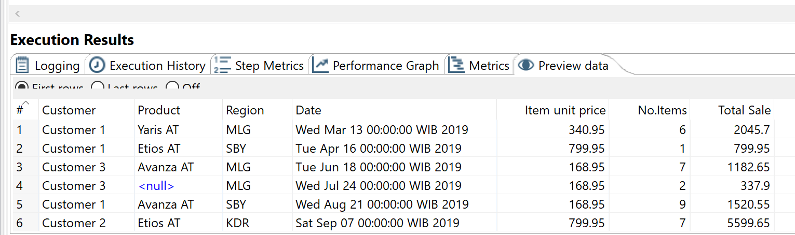

Jika langkah-langkah diatas telah berhasil, maka proses extract telah berhasil dilakukan.

**TUGAS 2**

1. Apakah data hasil eksekusi sesuai dengan data aslinya?
   * Ya, sudah sesuai
2. PDI Spoon melakukan proses extract, perhatikan pada **Tab Logging** di **Execution Results Area,** langkah-langkah apa sajakah yang dilakukan PDI Spoon untuk melakukan extract data?
3. Perhatikan gambar dibawah ini! Apa yang dimaksud dengan I,O,R,W,U,E ?



1. Berapa waktu yang dibutuhkan untuk melakukan eksekusi Extract data ini?
2. Bandingkan dengan 3 teman yang lain, identifikasi pula spesifikasi perangkat yang digunakan (Processor, RAM, Storage, VGA, CPU ). Bandingkan dalam bentuk tabel.